Database Concepts

Assignment 2, Semester 2, 2020

# Student Information

|  |  |
| --- | --- |
| Full Name | **VISHAL PATNAIK DAMODARAPATRUNI** |
| Student Number | **S3811521** |

# Assignment Declaration

When you submit work for assessment, you’ll be asked to agree to the following declaration.

1. I have not impersonated or allowed myself to be impersonated by any person for the purposes of this assessment.
2. This assessment is my/our original work and no part of it has been copied from any other source except where due acknowledgement is made.
3. No part of this assessment has been written for me/us by any other person except where such collaboration has been authorised by the lecturer/teacher concerned.
4. I have correctly acknowledged the re-use of any of my own previously submitted work within this submission.
5. I give permission for my assessment response to be reproduced, communicated compared and archived for the purposes of detecting plagiarism.
6. I give permission for a copy of my assessment to be retained by the university for review and comparison, including review by external examiners.

#### I understand that:

* Plagiarism is the presentation of the work, idea or creation of another person as though it is your own. It is a form of cheating and is a very serious academic offence that may lead to exclusion from the University. Plagiarised material can be drawn from, and presented in, written, graphic and visual form, including electronic data and oral presentations. Plagiarism occurs when the origin of the material used is not appropriately cited.
* Plagiarism includes the act of assisting or allowing another person to plagiarise or to copy my work.

#### I agree and acknowledge that:

1. I have read and understood the Declaration and Statement of Authorship above.

2. I accept that use of my RMIT account to electronically submit this assessment constitutes my agreement to the Declaration and Statement of Authorship

3. If I do not agree to the Declaration and Statement of Authorship in this context, the assessment outcome is not valid for assessment purposes and cannot be included in my aggregate score for this course.

You'll find more information about the penalties for plagiarism in the [Student Conduct Policy](https://www.rmit.edu.au/content/rmit-ui/en/about/governance-and-management/policies/student-conduct-policy.html).

# Compulsory Worklog Snapshots

Place your snapshots below. One snapshot showing the tables in your account. One snapshot including the SQL history for each connection session that you work on the assignment. **Your snapshots must be full screenshots** showing your connection details and the timestamps of each entry your SQL history – only copying the SQL history is not sufficient.

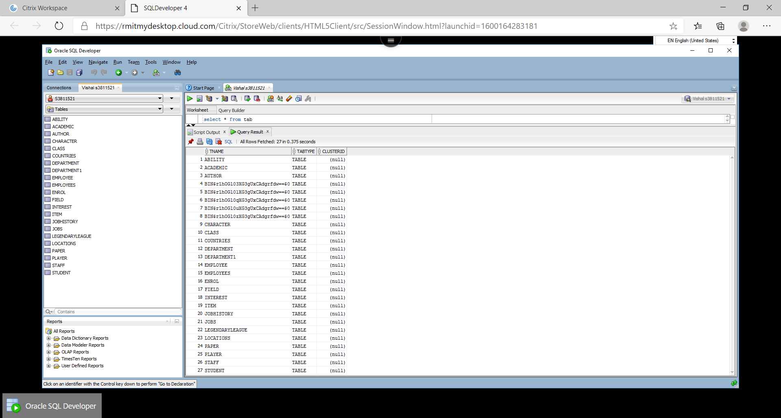

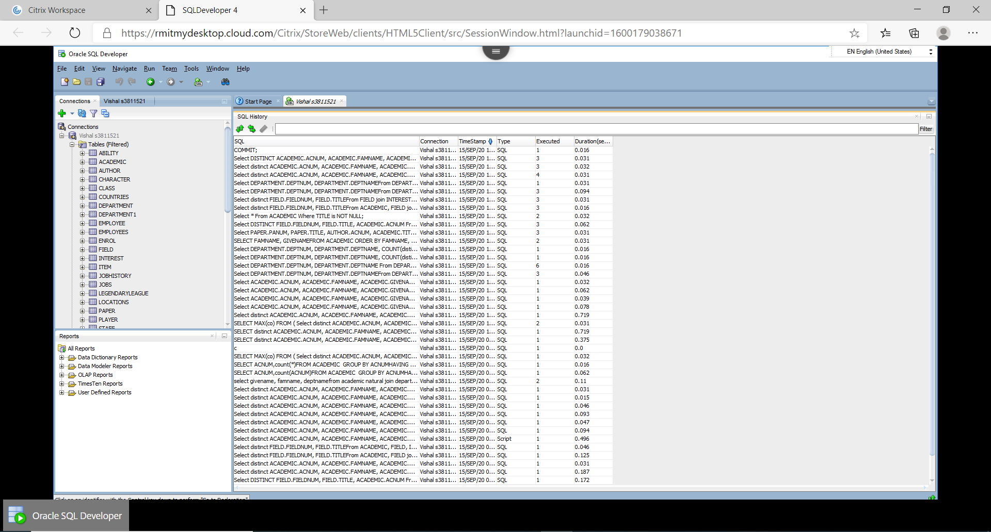

# Question 1

|  |  |
| --- | --- |
| **Reference number** | **QC1-14** |
| **Text of Your Question** | List the famname, givename of all academics in the database, in alphabetical order. |

The answer is as follows.

|  |
| --- |
| SELECT FAMNAME, GIVENAME  FROM ACADEMIC  ORDER BY FAMNAME, GIVENAME ASC; |

# Question 2

|  |  |
| --- | --- |
| **Reference number** | **QC1-12** |
| **Text of Your Question** | The query below is meant to list the panum, title and author acnum of papers and the academic title of each author, but it has errors. Give the correct SQL query.  Select panum, title From author. academic, paper Where author.acnum= academic.acnum; |

The answer is as follows.

|  |
| --- |
| Select PAPER.PANUM, PAPER.TITLE, AUTHOR.ACNUM, ACADEMIC.TITLE  From AUTHOR, ACADEMIC, PAPER  Where AUTHOR.PANUM = PAPER.PANUM and AUTHOR.ACNUM = ACADEMIC.ACNUM; |

# Question 3

|  |  |
| --- | --- |
| **Reference number** | **QC1-17** |
| **Text of Your Question** | List the fieldnum, title and academic acnum of each field. |

The answer is as follows.

|  |
| --- |
| Select FIELD.FIELDNUM, FIELD.TITLE, INTEREST.ACNUM as ACADEMIC_ACNUM  From FIELD join INTEREST on FIELD.FIELDNUM = INTEREST.FIELDNUM  Where INTEREST.ACNUM in (  Select ACADEMIC.ACNUM  From ACADEMIC join INTEREST ON ACADEMIC.ACNUM = INTEREST.ACNUM);  -- (OR)  Select FIELD.FIELDNUM, FIELD.TITLE, ACADEMIC.ACNUM  From ACADEMIC, FIELD, INTEREST  Where FIELD.FIELDNUM = INTEREST.FIELDNUM  and ACADEMIC.ACNUM = INTEREST.ACNUM; |

# Question 4

|  |  |
| --- | --- |
| **Reference number** | **QC1-16** |
| **Text of Your Question** | Find academics who have a title (title) available in the database. Write a query to return all details of these academics. |

The answer is as follows.

|  |
| --- |
| Select *  From ACADEMIC  Where TITLE is NOT NULL; |

# Question 5

|  |  |
| --- | --- |
| **Reference number** | **QC2-16** |
| **Text of Your Question** | Output in alphabetical order the acnum, famname, givename of academics whose family name starts with “C” and whose interested field number is larger than 3. |

The answer is as follows.

|  |
| --- |
| Select distinct ACADEMIC.ACNUM, ACADEMIC.FAMNAME, ACADEMIC.GIVENAME  From ACADEMIC join INTEREST on ACADEMIC.ACNUM = INTEREST.ACNUM  Where ACADEMIC.FAMNAME like 'C%'  and INTEREST.FIELDNUM > 3  Order By ACADEMIC.ACNUM, ACADEMIC.FAMNAME, ACADEMIC.GIVENAME; |

# Question 6

|  |  |
| --- | --- |
| **Reference number** | **QC2-13** |
| **Text of Your Question** | List the field number and title of fields interested by the academic whose acnum is 100. |

The answer is as follows.

|  |
| --- |
| Select distinct FIELD.FIELDNUM, FIELD.TITLE  From ACADEMIC, FIELD, INTEREST  Where FIELD.FIELDNUM = INTEREST.FIELDNUM  and ACADEMIC.ACNUM = INTEREST.ACNUM  and FIELD.FIELDNUM = 100;  -- (OR)  Select distinct FIELD.FIELDNUM, FIELD.TITLE  From FIELD join INTEREST on FIELD.FIELDNUM = INTEREST.FIELDNUM  Where INTEREST.ACNUM in (  Select ACADEMIC.ACNUM  From ACADEMIC join INTEREST ON ACADEMIC.ACNUM = INTEREST.ACNUM)  and FIELD.FIELDNUM = 100; |

# Question 7

|  |  |
| --- | --- |
| **Reference number** | **QC2-20** |
| **Text of Your Question** | List the deptnum and deptname of departments whose academics have never written any papers. You must use a subquery. |

The answer is as follows.

|  |
| --- |
| Select DEPARTMENT.DEPTNUM, DEPARTMENT.DEPTNAME  From DEPARTMENT, ACADEMIC  Where DEPARTMENT. DEPTNUM = ACADEMIC.DEPTNUM and ACADEMIC.ACNUM not in (  Select ACNUM  From AUTHOR); |

# Question 8

|  |  |
| --- | --- |
| **Reference number** | **QC2-18** |
| **Text of Your Question** | Find the departments that have covered at least ten fields (that is, those departments where the sum of fields interested by their academics is at least ten). Output their deptnum and deptname in ascending order. |

The answer is as follows.

|  |
| --- |
| Select DEPARTMENT.DEPTNUM, DEPARTMENT.DEPTNAME  From DEPARTMENT, ACADEMIC, INTEREST  Where DEPARTMENT.DEPTNUM = ACADEMIC.DEPTNUM  and ACADEMIC.ACNUM = INTEREST.ACNUM  Group by DEPARTMENT.DEPTNUM, DEPARTMENT.DEPTNAME  Having count (distinct INTEREST.FIELDNUM) >= 10  Order By DEPARTMENT.DEPTNUM, DEPARTMENT.DEPTNAME; |

# Question 9

|  |  |
| --- | --- |
| **Reference number** | **QC3-13** |
| **Text of Your Question** | Find the academics that have the largest number of interested fields. Output the details of these academics, including acnum, givename, famname, and the number of his/her interested fields. |

The answer is as follows.

|  |
| --- |
| Select distinct ACADEMIC.ACNUM, ACADEMIC.FAMNAME, ACADEMIC.GIVENAME, COUNT(INTEREST.FIELDNUM)  From ACADEMIC join INTEREST on ACADEMIC.ACNUM = INTEREST.ACNUM  Group By ACADEMIC.ACNUM, ACADEMIC.FAMNAME, ACADEMIC.GIVENAME  HAVING COUNT(FIELDNUM)>= all (  Select COUNT(INTEREST.FIELDNUM)  From ACADEMIC  Group By ACNUM)  ORDER BY COUNT(INTEREST.FIELDNUM) DESC; |

# Question 10

|  |  |
| --- | --- |
| **Reference number** | **QC3-14** |
| **Text of Your Question** | Find the academics who have not authored any paper with “Steve Bruce”. List their details (acnum, famname, givename, deptname, instname). |

The answer is as follows.

|  |
| --- |
| Select ACADEMIC.ACNUM, ACADEMIC.FAMNAME, ACADEMIC.GIVENAME, DEPARTMENT.DEPTNUM, DEPARTMENT.INSTNAME  From ACADEMIC join DEPARTMENT on ACADEMIC.DEPTNUM = DEPARTMENT.DEPTNUM  Where ACADEMIC.ACNUM not in  (Select ACADEMIC.ACNUM  From ACADEMIC join AUTHOR ON ACADEMIC.ACNUM = AUTHOR.ACNUM  Where ACADEMIC.FAMNAME = 'Bruce' and ACADEMIC.GIVENAME = 'Steve') |

# Question 11

|  |  |
| --- | --- |
| **Reference number** | **QC3-19** |
| **Text of Your Question** | Explain the following query in English. A literal explanation will receive 0 marks.  select givename, famname, deptname from academic natural join department where acnum not in (select acnum from academic natural join interest) and   deptNum in  (select deptNum             from academic natural join author group by deptNum having count(panum)>100); |

The answer is as follows.

|  |
| --- |
| This query selects and returns the Academic details (GIVENAME, FAMNAME) and the name of the department (DEPTNAME) that the academic belongs to and authored or co-authored more than 100 papers but have no interest in any field. |

# Question 12

|  |  |
| --- | --- |
| **Reference number** | **QC3-16** |
| **Text of Your Question** | The productivity of an academic is measured by the total number of paper s/he has written. Find the papers that have the most productive author/s or the least productive author/s. Output the acnum, title, and the givename, famname of the most productive author/s or the least productive author/s together with the number of their papers. |

The answer is as follows.

|  |
| --- |
| Select distinct ACADEMIC.ACNUM, ACADEMIC.FAMNAME, ACADEMIC.GIVENAME, COUNT(AUTHOR.PANUM) as PRODUCTIVITY  From ACADEMIC join AUTHOR on ACADEMIC.ACNUM = AUTHOR.ACNUM  Group By ACADEMIC.ACNUM, ACADEMIC.FAMNAME, ACADEMIC.GIVENAME  HAVING COUNT(AUTHOR.PANUM) >= all (  Select COUNT(AUTHOR.PANUM)  From ACADEMIC  Group By ACNUM)  ORDER BY COUNT(AUTHOR.PANUM) DESC; |